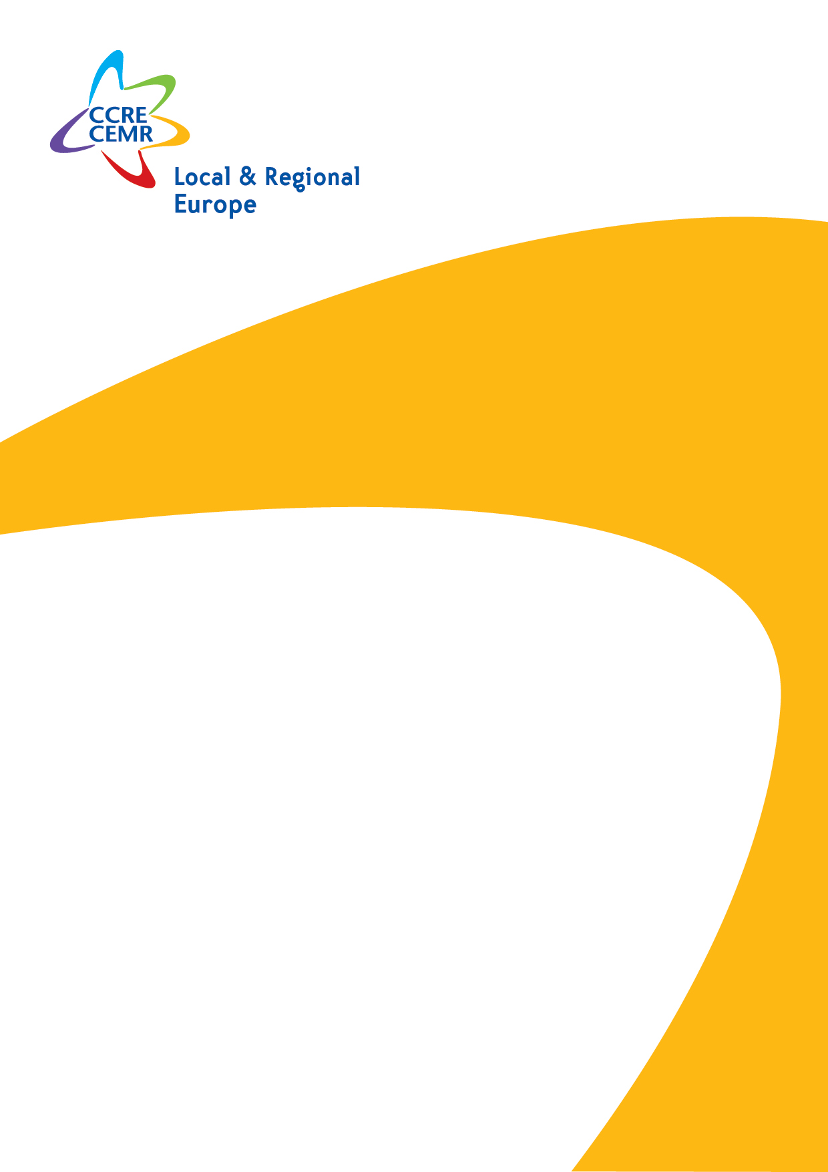

Application Pack

Officer
International Partnerships
Part-time position (80%) –
March 2021 – August 2022

Position based in Brussels
January 2021

Council of European Municipalities and Regions
European Section of United Cities and Local Governments
- Are you interested in the Eastern neighbourhood of the EU, and in particular in Ukraine?
- Do you want to help strengthening cities and towns in Ukraine and in the EU through decentralised development cooperation?
- Do you want to be part of a collaborative team where your competencies will be highly useful?
… then becoming Officer for International partnerships for the Council of European Municipalities and Regions (CEMR) and our upcoming project Bridges of Trust maybe your best choice: come work with us!
Bridges of Trust was developed in cooperation between CEMR-PLATFORMA and U-LEAD with Europe programme (Local Empowerment, Accountability and Development), a multi-donor action of the European Union and its Member States Denmark, Estonia, Germany, Poland and Sweden, led by GiZ.
You will be responsible for the activities of “Bridges of Trust: Empowering municipalities in Ukraine and in the European Union through building municipal partnerships”.
You will build on U-LEAD’s previous experience with establishing partnership between EU and Ukrainian municipalities. The focus will be to identify the potential for cooperation, define interests of municipalities, outline scopes of feasible joint actions, and bring them together to start planning measures on exchange of experience, skills and knowledge.
These activities are part of the broader work of the CEMR International Partnerships Team which covers our international activities, outreach and collaboration with international and global stakeholders, awareness-raising on the role of local and regional governments in achieving local and global policy goals, their empowerment towards internationalisation, with focus on decentralised development cooperation.

Your mission
- Plan and implement project activities based on the agreed roadmap included in the MoU signed between CEMR and GiZ;
- Map and analyse existing partnerships between Ukrainian and EU municipalities, and analyse socio-economic factors of target municipalities;
- Organise and facilitate virtual bilateral meetings;
- Organise study visits and internships, as well as respective kick-off and dissemination events;
- Coordinate with the donor, draft narrative and financial reports;
- Draft short articles, news items, and messages for the web site and social media (Twitter).

Your profile
- You have at least 3 years of experience in project management (planning, implementation, monitoring, reporting, evaluation)
- You have experience in working with local governments and/or their national associations, experience with international dimension of local government (town winning, sister cities, decentralised cooperation) an asset;
- You have experience with work in Ukraine, or other countries in the EU Neighbourhood East;
- You have skills in policy analysis, data processing and analysis;
- You have skills in organisation and logistics of virtual and physical events;
- You have good skills in communication, written and spoken presentation, facilitation of meetings;
- On the human side, you are a positive, reliable and autonomous person, but also keen on working in a team and you have strong interpersonal skills
- You are fluent in English and Russian/Ukrainian, a working knowledge of French or other European languages is an asset;
- You are willing to occasionally travel within Europe, as possible and necessary.

We offer
- A part-time contract (80%) of 18 months from 01 March 2021 until 31 August 2022, with possibility to extend to a full-time contract (100%) in the course of the contract;
- A valuable experience with local and regional governments, their associations, with international development donors;
- An open, international and flexible work environment;
- A modern, well-situated office in the European Quarter nearby Luxembourg Brussels Station, as well as teleworking possibilities.

Wishing to join us?
We are looking forward to meeting you!
Send your CV and application letter in English, telling us about your motivation and interest to: application.platforma@ccre-cemr.org no later than Monday 08 February 2021 at 12:00 CET.
Please put Officer – International partnerships in the subject of the email.
Interviews will take place online in February. Please note that only short-listed candidates will be contacted.

CEMR is an equal opportunity employer.
More about us: http://platforma-dev.eu/ - www.cemr.org

About CEMR

The Council of European Municipalities and Regions (CEMR) is the broadest organisation of local and regional authorities in Europe. Its members are over 60 national associations of municipalities and regions from 41 European countries. Together these associations represent some 150 000 local and regional authorities.

CEMR’s objectives are twofold: to influence European legislation on behalf of local and regional authorities and to provide a platform for exchange between its member associations and their elected officials and experts.

Moreover, CEMR is the European section of United Cities and Local Governments (UCLG), the worldwide organisation of local government.

www.ccre.org

